SCHOOL OF COMPUTER SCIENCE AND ARTIFICIAL INTELLIGENCE |  |  |  |  | DEPARTMENT OF COMPUTER SCIENCE ENGINEERING
Program Name: B. Tech |  |  |  | Assignment Type: Lab |  |  | Academic Year:2025-2026
Course Coordinator Name |  |  |  | Dr. Rishabh Mittal
Instructor(s) Name |  |  |  | Mr. S Naresh Kumar  Ms. B. Swathi  Dr. Sasanko Shekhar Gantayat  Mr. Md Sallauddin  Dr. Mathivanan  Mr. Y Srikanth  Ms. N Shilpa  Dr. Rishabh Mittal (Coordinator)  Dr. R. Prashant Kumar  Mr. Ankushavali MD  Mr. B Viswanath  Ms. Sujitha Reddy  Ms. A. Anitha  Ms. M.Madhuri  Ms. Katherashala Swetha  Ms. Velpula sumalatha  Mr. Bingi Raju
CourseCode |  |  | 23CS002PC304 | Course Title |  | AI Assisted Coding
Year/Sem |  |  | III/II | Regulation |  | R23
Date and Day  of Assignment |  |  | Week3 – Wednusday | Time(s) |  | 23CSBTB01 To 23CSBTB52
Duration |  |  | 2 Hours | Applicable to  Batches |  | All batches
Assignment Number:8.3(Present assignment number)/24(Total number of assignments)
 | Q.No. | Question |  |  |  |  |  | ExpectedTime  to complete
 | 1 | Lab 8: Test-Driven Development with AI – Generating and Working with Test Cases  Lab Objectives  • Introduce TDD using AI  • Generate test cases before implementation  • Emphasize testing and validation  • Encourage clean, reliable code  Lab Outcomes  Students will be able to:  • Write AI-generated test cases  • Implement code using test-first approach  • Validate using unittest  • Analyze test coverage  • Compare AI vs manual tests  Task 1: Email Validation using TDD  Scenario  You are developing a user registration system that requires reliable email input validation.  Requirements  • Must contain @ and . characters  • Must not start or end with special characters  • Should not allow multiple @ symbols  • AI should generate test cases covering valid and invalid email formats  • Implement is_valid_email(email) to pass all AI-generated test cases  Expected Output  • Python function for email validation  • All AI-generated test cases pass successfully  • Invalid email formats are correctly rejected  • Valid email formats return True  Prompt:-  Generate Python email validation using TDD.First create valid and invalid email test cases.  Then implement is_valid_email(email) such that: it contains exactly one '@'and contains '.'  Also it should no start/end with special characters and no multiple '@'Valid emails return True, invalid return False. No regex. Simple code.  Code:-  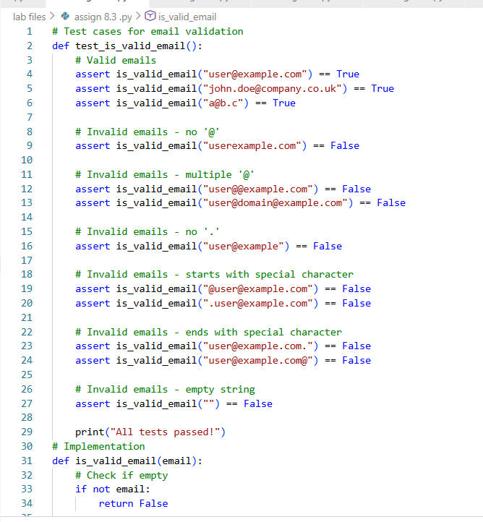  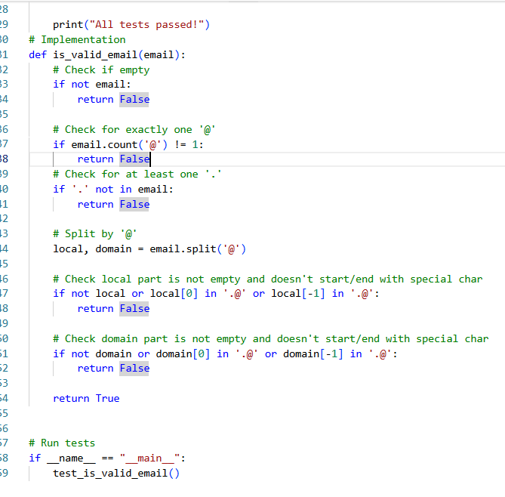  Output:-  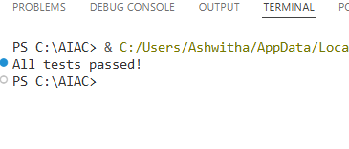  Explanation:-  is_valid_email() checks if the input is a proper email by using a regex pattern and some extra rules (length, dots, @ symbol).If the email format is correct and follows all conditions, it returns True, otherwise False.The unittest class runs many test cases to automatically check whether the function works for valid and invalid emails.  Task 2: Grade Assignment using Loops  Scenario  You are building an automated grading system for an online examination platform.  Requirements  • AI should generate test cases for assign_grade(score) where:  – 90–100 → A  – 80–89 → B  – 70–79 → C  – 60–69 → D  – Below 60 → F  • Include boundary values (60, 70, 80, 90)  • Include invalid inputs such as -5, 105, "eighty"  • Implement the function using a test-driven approach  Expected Output  • Grade assignment function implemented in Python  • Boundary values handled correctly  • Invalid inputs handled gracefully  • All AI-generated test cases pass  Prompt:-  Generate Python code using TDD for grade assignment.  Create test cases first (valid, boundary, and invalid inputs).  Then implement assign_grade(score) using loops/conditions:  90–100 A, 80–89 B, 70–79 C, 60–69 D, below 60 F.  Handle invalid inputs gracefully.  Code:-  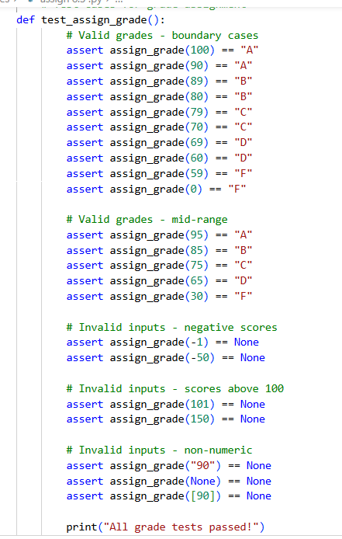  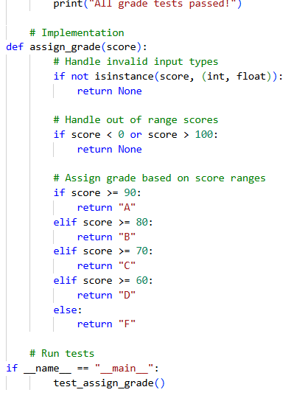  Output:-  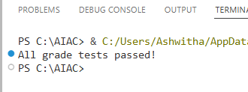  Explanation:-  Using Test-Driven Development, test cases were created first including boundary and invalid values.  The assign_grade() function was then implemented using conditional loops to meet grading rules.  Invalid inputs such as negative numbers, out-of-range values, and non-numeric inputs are handled gracefully.  Task 3: Sentence Palindrome Checker  Scenario  You are developing a text-processing utility to analyze sentences.  Requirements  • AI should generate test cases for is_sentence_palindrome(sentence)  • Ignore case, spaces, and punctuation  • Test both palindromic and non-palindromic sentences  • Example:  – "A man a plan a canal Panama" → True  Expected Output  • Function correctly identifies sentence palindromes  • Case and punctuation are ignored  • Returns True or False accurately  • All AI-generated test cases pass  Prompt:-  Generate Python code using TDD for sentence palindrome checking where it should First create test cases with palindromic and non-palindromic sentencesIgnore case, spaces, and punctuation.  Then implement is_sentence_palindrome(sentence).  Return True or False.  Code:-  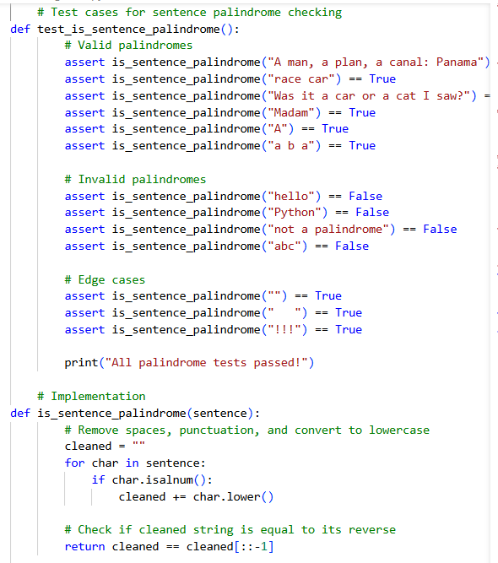  Output:-  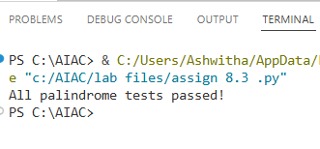  Explanation:-  Using Test-Driven Development, test cases were created first for both palindromic and non-palindromic sentences.The function removes spaces, punctuation, and ignores case before checking if the sentence reads the same forwards and backwards.All AI-generated test cases pass, and the function accurately returns True or False.  Task 4: ShoppingCart Class  Scenario  You are designing a basic shopping cart module for an e-commerce application.  Requirements  • AI should generate test cases for the ShoppingCart class  • Class must include the following methods:  – add_item(name, price)  – remove_item(name)  – total_cost()  • Validate correct addition, removal, and cost calculation  • Handle empty cart scenarios  Expected Output  • Fully implemented ShoppingCart class  • All methods pass AI-generated test cases  • Total cost is calculated accurately  • Items are added and removed correctly  Prompt:  Generate Python code using TDD for a ShoppingCart class.First create test cases.Class should support: add_item(name, price)remove_item(name) total_cost()Validate item addition, removal, total cost calculation,and handle empty cart cases.  Code:-  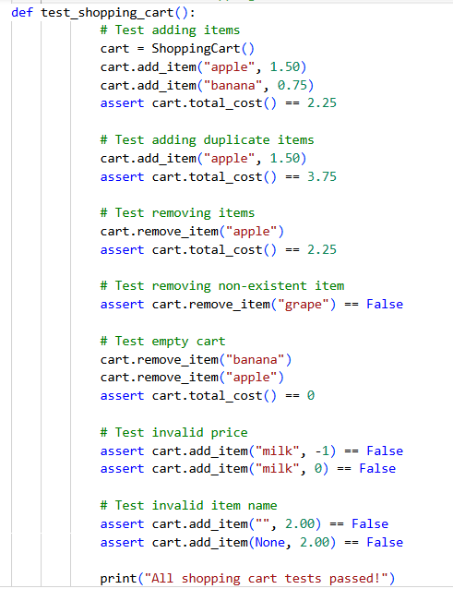  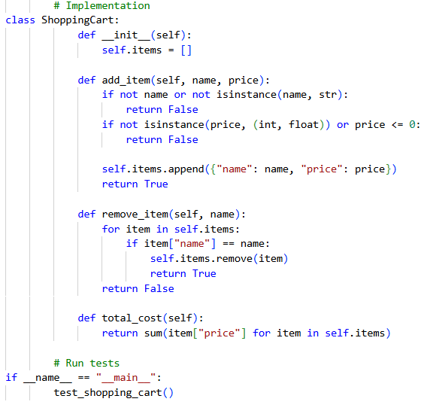  Output:-  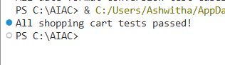  Explanation:-  This program checks whether a shopping cart works properly. It adds items with valid names and prices, removes items when needed, and calculates the total cost of all items in the cart. It also handles special cases like adding invalid items, removing items that are not present, and working with an empty cart. If all these checks work correctly, the program confirms it by printing that all shopping cart tests have passed.  Task 5: Date Format Conversion  Scenario  You are creating a utility function to convert date formats for reports.  Requirements  • AI should generate test cases for convert_date_format(date_str)  • Input format must be "YYYY-MM-DD"  • Output format must be "DD-MM-YYYY"  • Example:  – "2023-10-15" → "15-10-2023"  Expected Output  • Date conversion function implemented in Python  • Correct format conversion for all valid inputs  • All AI-generated test cases pass successfully  Prompt:-  Generate Python code using TDD for date format conversion.  Create test cases first.  Convert date from "YYYY-MM-DD" to "DD-MM-YYYY".  Implement convert_date_format(date_str).  Ensure all test cases pass.  Keep the solution simple.  Code:-  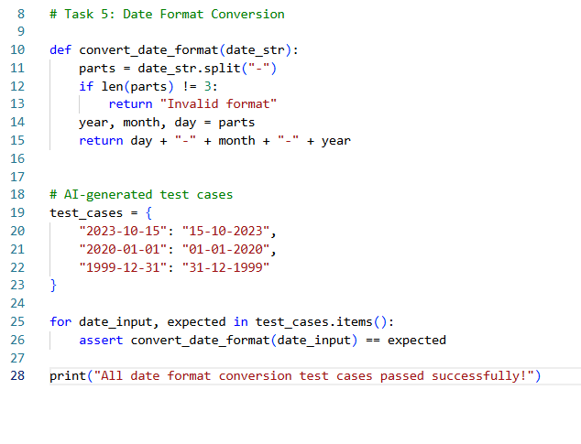  Output:-  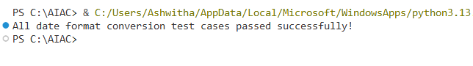  Explanation:-  This program changes the date format from YYYY-MM-DD to DD-MM-YYYY.  First, the date is split using the - symbol to separate the year, month, and day.  Then, these parts are rearranged to form the new format.  Note: Report should be submitted as a word document for all tasks in a single document with prompts, comments & code explanation, and output and if required, screenshots. |  |  |  |  |  | Week4 - Wednesday

